A000-AM,C-Taino-Pestle-Zoomorphic-Anthropomorphic-Porphyritic Andesite-1000 CE

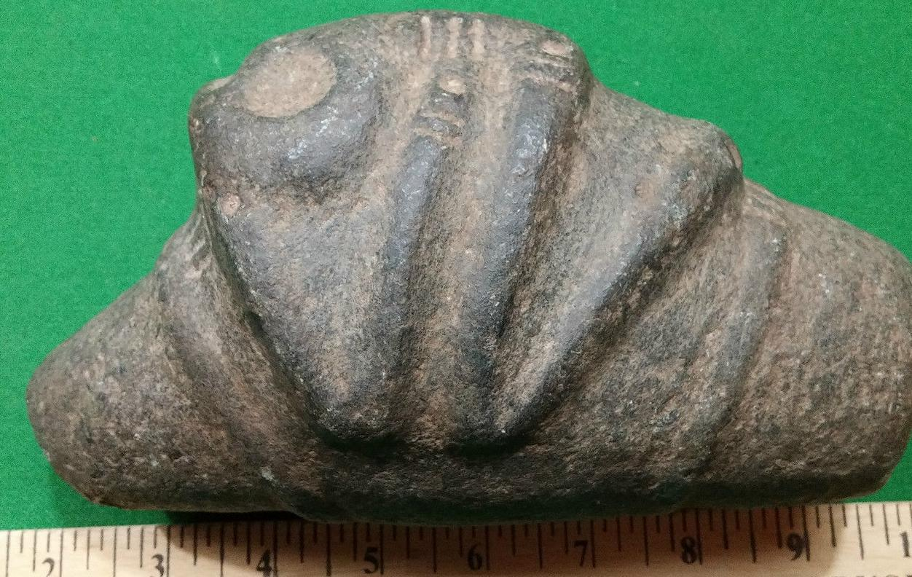

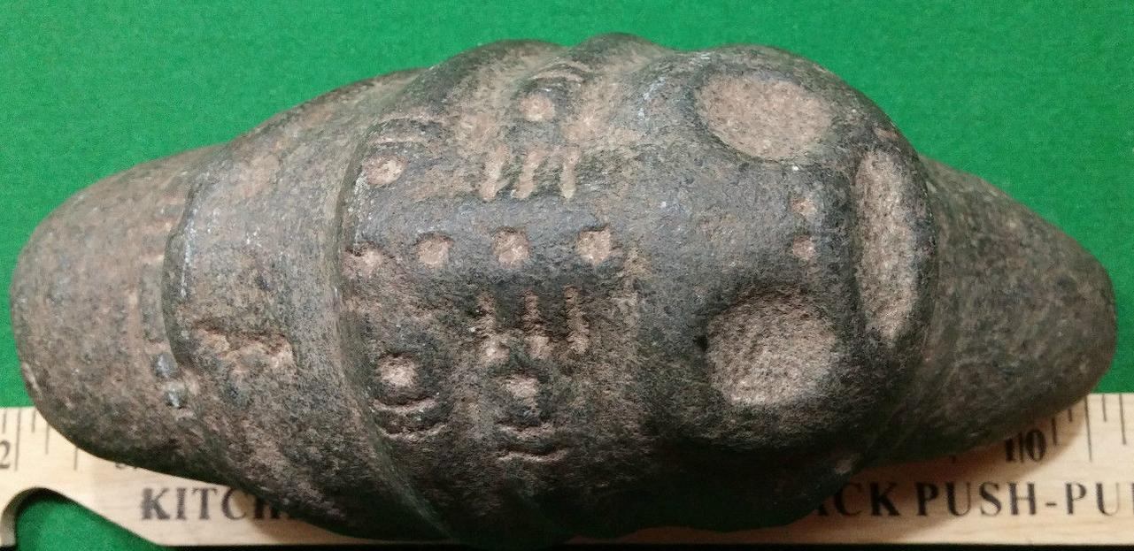

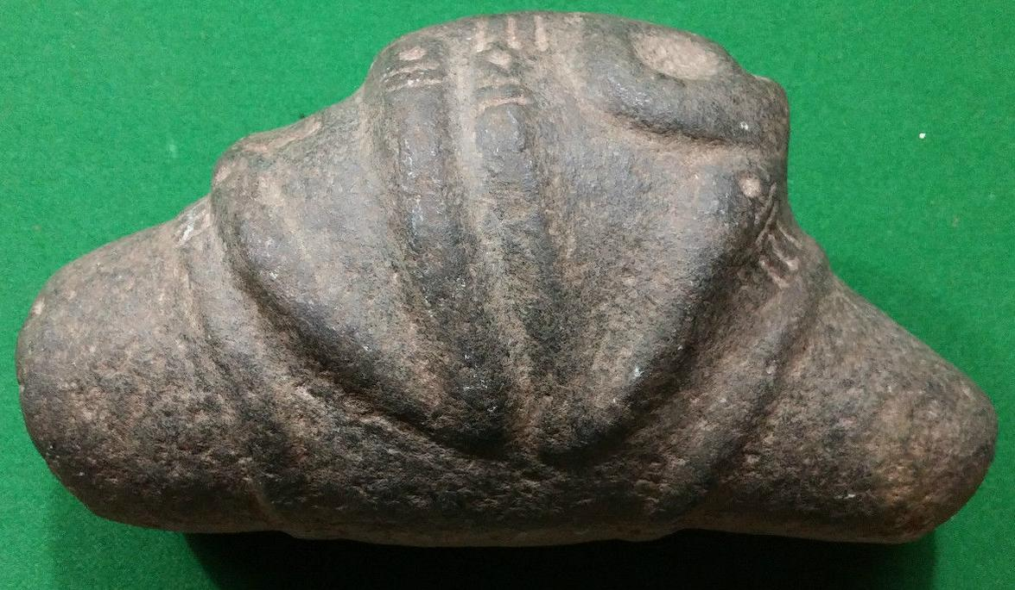

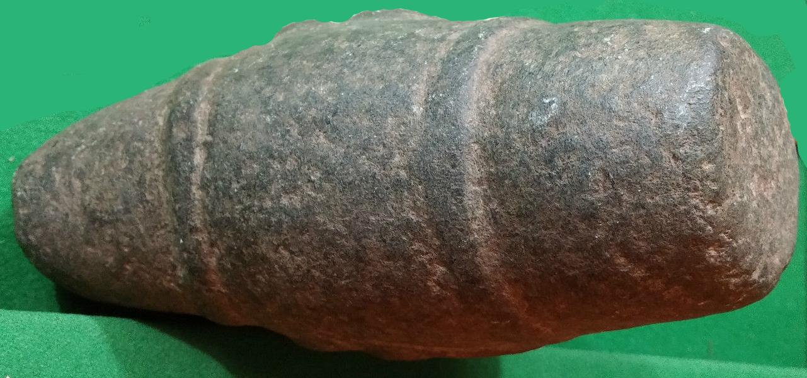

Figs. 1-4. AM,C-Taino-Pestle-Zoomorphic-Anthropomorphic-Porphyritic Andesite-1000 CE

Case No.: 18

**Accession No.**

**Formal Label** AM,C-Taino-Pestle-Zoomorphic-Anthropomorphic-Porphyritic Andesite-1000 CE

**Display Description:**

The duality of a zoomorph and an anthropomorph is a feature of Taino graphic representation of the animal into which spirit the shaman has been transformed.

**The Ritual of Cohoba** The ritual of cohoba was the most important ceremony Taino. The chiefs, male members of their class - nitaínos - and -chamanes- behiques participating in it to consult cemíes about important community events.According to He describes Dr. Rivero de la Calle (1986):   
Cohoba consisted of hallucinogenic powders, which initially was estimated obtained solely of snuff and is absorbed in an inhaler was introduced in the nose. This ceremony was preceded by a purification; which consists of a ritual vomiting, which was willing to let the individual to abosorber these powders. Overall the rite of purification; and inhalation of hallucinogenic powder was part of the most complex operations that performed the cacique and behique both for healing purposes, and the most important rites, from the collective point of view, through which they proceeded after to be in the appropriate state to guess toxic issues that were of interest to the community, especially for the cacique or behique (2).   
  
In the Ritual of Cohoba they intervened a toolkit or artifacts of a certain connotation. These were:   
.The Spatula vomica, with which caused vomiting.   
.The Tray where hallucinogenic powders were placed.   
.The Inhaler in the form of "Y", which was introduced in the nose.   
.The Duced or wooden seat where behique or cacique sat.   
.The Idol before which the ritual unfolded.   
It consisted of inhalation, preceded by a purifying vomiting, hallucinogenic substances that caused a state of ecstasy that allowed communication with deities or cemíes.

He described [Bartolome de las Casas](https://translate.googleusercontent.com/translate_c?depth=1&hl=en&prev=search&rurl=translate.google.com&sl=es&u=http://pueblosoriginarios.com/biografias/casas.html&usg=ALkJrhiEbDcTJHKW_RGwJDqX2B_AbcHbLg) in Apologetic History Summary (1559):

"The first thing the beginning was the master, and while he made ​​her all silent, took his cohoba (which is sniff the powders, as has been said), and tomábase seated on low banquets, but nicely styled which called duhos ... was a while back her head to one side and arms above her knees, then lifted his face to the sky speaking their certain words, they should be your prayer to the true God or who had God, answered all then quasi as when we respond to love, and this made ​​with big name voices and sounds, captándole benevolence and begging him to say what he had seen gave account of his vision, saying the Cemi had him. speaking and certificate of good times or adverse, or had had children, or that they had died, or had to have some containment or war with its neighbors. "

**LC Classification: F1909**

**Date or Time Horizon: 1000 CE**

**Geographical Area: Dominican Republic**

**Map:**

**GPS coordinates:**

**Cultural Affiliation:**

**Medium: porphyritic andesite**

**Dimensions:**

**Weight:**

**Condition: original**

**Provenance: Dominican Republic**

**Discussion:**

As an example of interest, documentary evidence these ritual practices, existing pictographs can be mentioned in the Cave of Bourbon in Dominican Republic where it is represented a group of Aboriginal performing the Ritual of Cohoba.

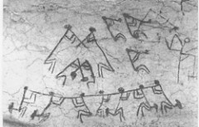

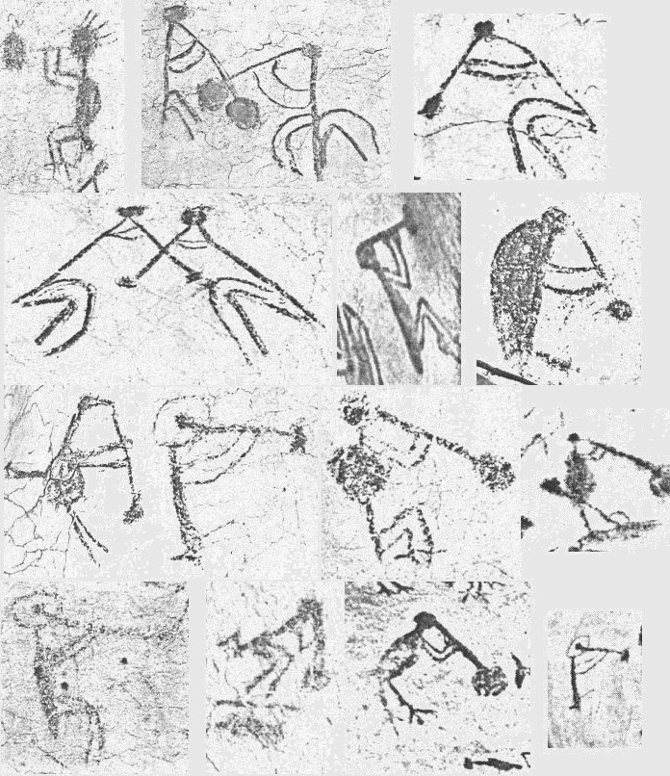

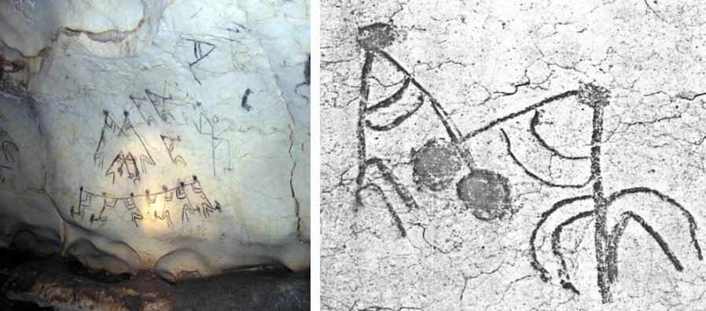  
Pictographs on the Cueva de Borbón, Dominican Republic. The scene shows a group of men performing the ritual.  
  
Regarding the hallucinogenic powders in general [...] the use of hallucinogens has been a very old and widespread custom in indigenous communities of America. Flowers, branches, bark, seeds, cactus and vines have been used in a variety of manifestations of these peoples. Traditional medicine, rituals, ceremonies, festivals and customs are full of examples of their use (3).

De las Casas: "... they had made certain powders of certain very dry and finely ground herbs, color of cinnamon or ground henna, in short, were tawny color."

Prior to the ceremony, which usually took place in the house of the chief, were purified by induced vomiting with a spatula. The instrument was made of wood or manatee ribs, decorated with figures.

Participants decorated and painted their bodies

On the head of a cemí which served as tray- it stood "... a most beautiful gold plate round, not flat, but a little something warped or deep, made of wood, so beautiful, smooth and cute that was not or silver; it was almost black and pike like jet "(Bartolome de las Casas) with hallucinogens powders.

Upon entering the premises, they were received by the chief, who played -tambor wood or bamboo-mayohabao. Cemí sat around the squat, hands on knees

The powders were inhaled with a Y-shaped canutos, Bartolome de las Casas compares with a hollow flute:

"... Two-thirds of which will henceforth be opened by two hollow internodes, just as we opened the two middle fingers, pulling the thumb, when we reach out. Those two joints, two positions in both windows nostrils, and the beginning of the flute, say, powders were at home, sipping the gap rescebían sucking in and out of your nostrils the amount of powder to take determined, which rescebidos, leaving after of the brain or quasi like strong drink wine, where they were drunk or quasi drunk ... "

After entering ecstasy, the chief sat in his duho or ceremonial bank could then make inquiries to cemí.

The duhos were low and well-styled and were considered one of the most beautiful expressions of Taino art, made of mahogany or guayacán and often carved with representations of animals.

**References:**